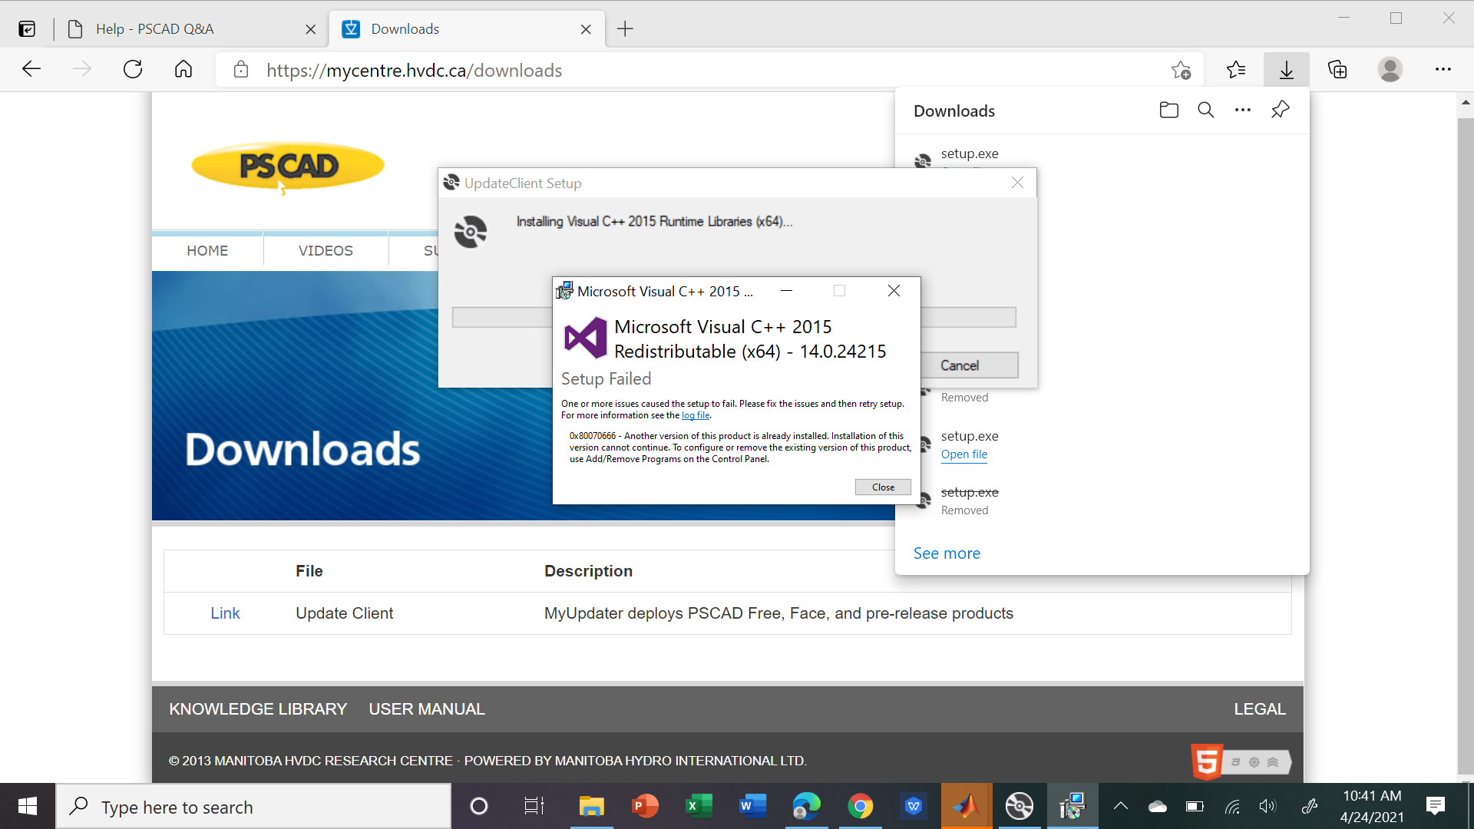
Log File:
[0E08:285C][2021-04-24T10:40:09]i001: Burn v3.7.3813.0, Windows v10.0 (Build 19041: Service Pack 0), path: C:\Users\faris\AppData\Local\Temp\VSDAC48.tmp\vcredist_x64\vcredist_x64.exe, cmdline: '/q:a '
[0E08:285C][2021-04-24T10:40:09]i000: Setting string variable 'WixBundleLog' to value 'C:\Users\faris\AppData\Local\Temp\dd_vcredist_amd64_20210424104009.log'
[0E08:285C][2021-04-24T10:40:09]i000: Setting string variable 'WixBundleOriginalSource' to value 'C:\Users\faris\AppData\Local\Temp\VSDAC48.tmp\vcredist_x64\vcredist_x64.exe'
[0E08:285C][2021-04-24T10:40:09]i000: Setting string variable 'WixBundleOriginalSourceFolder' to value 'C:\Users\faris\AppData\Local\Temp\VSDAC48.tmp\vcredist_x64\'
[0E08:285C][2021-04-24T10:40:09]i000: Setting string variable 'WixBundleName' to value 'Microsoft Visual C++ 2015 Redistributable (x64) - 14.0.24215'
[0E08:285C][2021-04-24T10:40:10]i100: Detect begin, 10 packages
[0E08:285C][2021-04-24T10:40:10]i000: Setting version variable 'windows_uCRT_DetectKey' to value '10.0.19041.789'
[0E08:285C][2021-04-24T10:40:10]i000: Setting numeric variable 'windows_uCRT_DetectKeyExists' to value 1
[0E08:285C][2021-04-24T10:40:10]i102: Detected related bundle: {282975d8-55fe-4991-bbbb-06a72581ce58}, type: Upgrade, scope: PerMachine, version: 14.24.28127.4, operation: Downgrade
[0E08:285C][2021-04-24T10:40:10]i108: Detected compatible package: vcRuntimeMinimum_x64, provider: Microsoft.VS.VC_RuntimeMinimumVSU_amd64,v14, installed: {7DC387B8-E6A2-480C-8EF9-A6E51AE81C19}, version: 14.24.28127, chained: {50A2BC33-C9CD-3BF1-A8FF-53C10A0B183C}
[0E08:285C][2021-04-24T10:40:10]i103: Detected related package: {7DC387B8-E6A2-480C-8EF9-A6E51AE81C19}, scope: PerMachine, version: 14.24.28127.0, language: 0 operation: Downgrade
[0E08:285C][2021-04-24T10:40:10]i108: Detected compatible package: vcRuntimeAdditional_x64, provider: Microsoft.VS.VC_RuntimeAdditionalVSU_amd64,v14, installed: {8678BA04-D161-45BE-ACA4-CC5D13073F35}, version: 14.24.28127, chained: {EF1EC6A9-17DE-3DA9-B040-686A1E8A8B04}
[0E08:285C][2021-04-24T10:40:10]i103: Detected related package: {8678BA04-D161-45BE-ACA4-CC5D13073F35}, scope: PerMachine, version: 14.24.28127.0, language: 0 operation: Downgrade
[0E08:285C][2021-04-24T10:40:10]i052: Condition '(VersionNT = v6.3 AND NOT VersionNT64) AND (windows_uCRT_DetectKeyExists AND windows_uCRT_DetectKey >= v10.0.10240.0)' evaluates to false.
[0E08:285C][2021-04-24T10:40:10]i052: Condition '(VersionNT = v6.3 AND VersionNT64) AND (windows_uCRT_DetectKeyExists AND windows_uCRT_DetectKey >= v10.0.10240.0)' evaluates to false.
[0E08:285C][2021-04-24T10:40:10]i052: Condition '(VersionNT = v6.2 AND NOT VersionNT64) AND (windows_uCRT_DetectKeyExists AND windows_uCRT_DetectKey >= v10.0.10240.0)' evaluates to false.
[0E08:285C][2021-04-24T10:40:10]i052: Condition '(VersionNT = v6.2 AND VersionNT64) AND (windows_uCRT_DetectKeyExists AND windows_uCRT_DetectKey >= v10.0.10240.0)' evaluates to false.
[0E08:285C][2021-04-24T10:40:10]i052: Condition '(VersionNT = v6.1 AND NOT VersionNT64) AND (windows_uCRT_DetectKeyExists AND windows_uCRT_DetectKey >= v10.0.10240.0)' evaluates to false.
[0E08:285C][2021-04-24T10:40:10]i052: Condition '(VersionNT = v6.1 AND VersionNT64) AND (windows_uCRT_DetectKeyExists AND windows_uCRT_DetectKey >= v10.0.10240.0)' evaluates to false.
[0E08:285C][2021-04-24T10:40:10]i052: Condition '(VersionNT = v6.0 AND NOT VersionNT64) AND (windows_uCRT_DetectKeyExists AND windows_uCRT_DetectKey >= v10.0.10240.0)' evaluates to false.
[0E08:285C][2021-04-24T10:40:10]i052: Condition '(VersionNT = v6.0 AND VersionNT64) AND (windows_uCRT_DetectKeyExists AND windows_uCRT_DetectKey >= v10.0.10240.0)' evaluates to false.
[0E08:285C][2021-04-24T10:40:10]i101: Detected package: vcRuntimeMinimum_x64, state: Obsolete, cached: None
[0E08:285C][2021-04-24T10:40:10]i101: Detected package: vcRuntimeAdditional_x64, state: Obsolete, cached: None
[0E08:285C][2021-04-24T10:40:10]i101: Detected package: Windows81_x86, state: Absent, cached: None
[0E08:285C][2021-04-24T10:40:10]i101: Detected package: Windows81_x64, state: Absent, cached: None
[0E08:285C][2021-04-24T10:40:10]i101: Detected package: Windows8_x86, state: Absent, cached: None
[0E08:285C][2021-04-24T10:40:10]i101: Detected package: Windows8_x64, state: Absent, cached: None
[0E08:285C][2021-04-24T10:40:10]i101: Detected package: Windows7_MSU_x86, state: Absent, cached: None
[0E08:285C][2021-04-24T10:40:10]i101: Detected package: Windows7_MSU_x64, state: Absent, cached: None
[0E08:285C][2021-04-24T10:40:10]i101: Detected package: WindowsVista_MSU_x86, state: Absent, cached: None
[0E08:285C][2021-04-24T10:40:10]i101: Detected package: WindowsVista_MSU_x64, state: Absent, cached: None
[0E08:285C][2021-04-24T10:40:10]i052: Condition 'VersionNT64 >= v6.0 OR (VersionNT64 = v5.2 AND ServicePackLevel >= 1)' evaluates to true.
[0E08:285C][2021-04-24T10:40:10]i199: Detect complete, result: 0x0
[0E08:1468][2021-04-24T10:40:19]e000: Error 0x80070666: Cannot install a product when a newer version is installed.

